As it is officially ‘half term’ this week, we will not be sending any formal work home but instead asking you to focus on Wellbeing.
Below are a selection of suggested activities for you to try if you would like to.
Be grateful for what you do have, instead of focusing on what you don't have and start a happiness jar.    Find a jar and write down on a piece of paper one good thing that has happened or one thing you are grateful for that day, fold it up and pop it into the jar.  Continue this everyday and you'll have plenty of wonderful memories to reflect on if you are feeling down. |  | 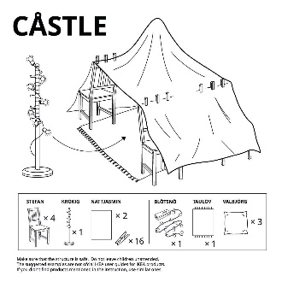  Ikea have released some amazing ideas for den building.  Why not see if you can build a den?  Use your den for some quiet time, why not have some reflection time. draw or read a book in your new den?  https://secretmanchester.com/ikea-fort-instructions/
  Go for a walk in nature and take time to notice things around you in detail, use all your senses, not just your eyes.  Sit down within nature and have a go at the ‘Sounds of Silence’ activity you can find here:  https://childhoodbynature.com/tuning-into-the-sounds-of-nature/ | Wellbeing  Week   |  | Get creative! Why not create a kindness calendar with an act of kindness that you and your family can do each day!    Have a look at an example below:  https://www.actionforhappiness.org/kindness-calendar
How about some relaxing yoga and mindfulness?    ‘Cosmic Kids’ offer fun yoga, mindfulness and relaxation videos on Youtube.  Follow the link below to have a go:  https://www.youtube.com/user/CosmicKidsYoga |  | Before you go to sleep, ask yourself:  - Who or what made you happy today?    - How did you make someone else happy?  - What did you learn today?  - What can you do tomorrow to make yourself and others happy?

