Activities

1 | Stone Age – Prehistoric Animals  We are going to become experts on Stone Age animals!    Work through the powerpoint about Prehistoric Beasts and use the internet to further your research.  Choose a selection of prehistoric beasts to create a Stone Age Safari guide about.
2 | Music 4 Harmony  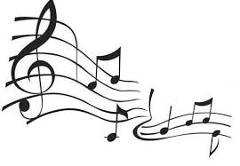  This is where a group plays or sings more than one pitched note at the same time. Many harmonies are made up of chords. A chord is when two or three pitched notes are played at the same time. Watch this video:https://www.bbc.co.uk/bitesize/topics/zcbkcj6/articles/zgxx2nb to find out more about it.
3 | Computing    Read the information about how computers control robots at https://www.bbc.co.uk/bitesize/topics/zs7s4wx/articles/zxjsfg8  and watch the video clip about robotics, sensors and motors.
4 | French - At The Garage Sale  Watch the video at: https://www.bbc.co.uk/bitesize/clips/zs3hfg8  Practise pronouncing these French words: le vide grenier (garage sale),  des jouets (some toys),  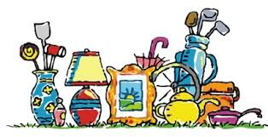  des chapeaux (some hats),  un tricycle (a tricycle),  des patins (some skates),  des vidéos (some videos),  des livres (some books)  Can you work out what the other words mean in the market?
5 | Creative Learning – Design an Book Token  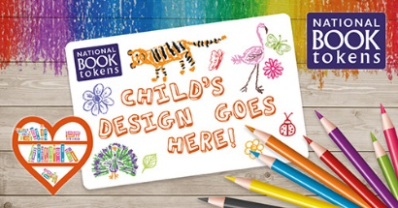  Win a £10 National Book Token for each of your classmates – and surprise them all when school reopens!  Click on the link to see the details and download an entry form:  https://www.nationalbooktokens.com/create-a-national-book-token-for-your-class  Closing date for entries is Sunday 28th June 2020
St. Oswald’s Home Learning - Year 3/4: Week 7 - Week Beginning 1.6.20

If you would like to continue to access the Literacy and Numeracy work you can do so using the links below, clicking on the relevant year group.
Literacy - https://www.hamilton-trust.org.uk/blog/learning-home-packs/ (Week 9)
Numeracy - https://whiterosemaths.com/homelearning/
(The numeracy worksheets are available from the school website home learning page)

There are also lots of good activities on https://www.bbc.co.uk/bitesize and you can continue to practise your skills on TTRockstars and Read Theory.

