Activities

1 | 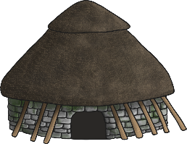  Stone Age – Houses  Look at the powerpoint about Stone Age homes and read through the information.  Complete the activity, drawing the homes from each time period and labelling the materials used.
2 | Art    Could you be J.K Rowling’s new illustrator?  Read J.K. Rowling's The Ickabog at www.theickabog.com and have a go at creating some artwork for the chapter.  Check out the illustration themes each weekday when a new installment of the story is posted and get creative!
3 | Computing – Hour of Code  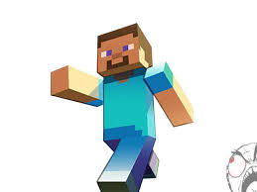  Use the following link: https://code.org/minecraft to journey through Minecraft with code.  Can you solve the problems along the way to complete the ‘Voyage Aquatic section, exploring and building underwater worlds with code?
4 | Well-Being    Remember to look after yourself and take some time to reflect on things.  Have a go at filling in the ‘Weekly Wellbeing Journal’ with an activity for each day for you to try,
5 | Creative Learning – Dance Moves  In this activity, children will make up a dance routine and create the instructions for a partner to follow.    Find the instructions here: https://www.barefootcomputing.org/docs/default-source/at-home/dance_moves_activity.pdf?sfvrsn=c15391ea_2 and the printable dance cards here: https://www.barefootcomputing.org/docs/default-source/at-home/dance_moves_supporting_worksheets.pdf?sfvrsn=754791ea_0 or have some fun making up your own!
St. Oswald’s Home Learning - Year 3/4: Week 8 - Week Beginning 8.6.20

If you would like to continue to access the Literacy and Numeracy work you can do so using the links below, clicking on the relevant year group.
Literacy - https://www.hamilton-trust.org.uk/blog/learning-home-packs/ (Week 10)
Numeracy - https://whiterosemaths.com/homelearning/
(The numeracy worksheets are available from the school website home learning page)

There are also lots of good activities on https://www.bbc.co.uk/bitesize and you can continue to practise your skills on TTRockstars and Read Theory.

