St. Oswald’s Home Learning Class 2: Week 4 - Week Beginning 4.5.20:
 | Activities
1 | Find out about VE Day  Friday is VE Day. Read the fact sheet to find out about VE day. Have a go at answering the questions to show what you’ve learned.  Extension: Use the internet to find out about the life of Captain Tom Moore.  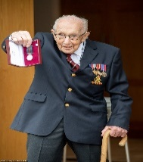
2 | Design a medal  Design a VE Day medal. Use the sheet provided to look at the design of the medals and to help think about what you might make. Can you take a picture of it, it would be lovely to see your medals! Send them to us at school.  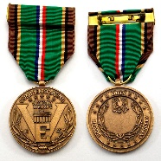
3 | Singing  Follow the link to listen to the Horrible Histories VE Day song https://www.bbc.co.uk/cbbc/watch/horrible-histories-songs-ve-day-song?collection=horrible-histories-songs  Use YouTube to listen to Vera Lynn sing We’ll Meet Again, a very famous song from this time. Try joining in with parts.  Extension: Learn how to swing dance! https://safeyoutube.net/w/cXI7
4 | Wartime Recipes  Find out what families were eating over 75 years ago. Pick a recipe (in the resources section) and have some fun baking.  Extension: Write instructions to show others how to make your yummy treats.  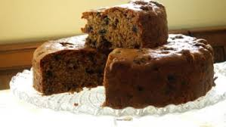
5 | Life in the past  Use an old cereal box to design and make a suitcase. What important things would you take with you? Can you draw these objects and pack them into your suitcase?  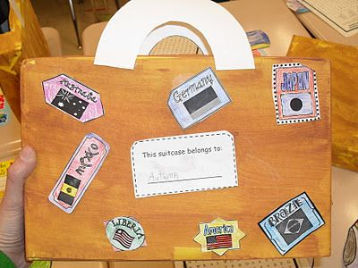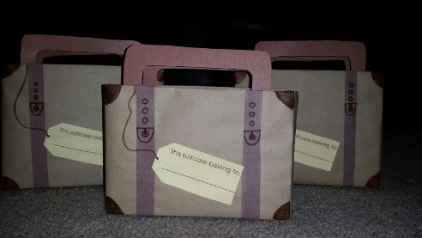

If you would like to continue to access the Literacy and Numeracy work you can do so using the links below, clicking on the relevant year group.
Literacy - https://www.hamilton-trust.org.uk/blog/learning-home-packs/
Numeracy - https://whiterosemaths.com/homelearning/

There are also lots of good activities on https://www.bbc.co.uk/bitesize and you can continue to practise your skills on TTRockstars and SPAG.com

