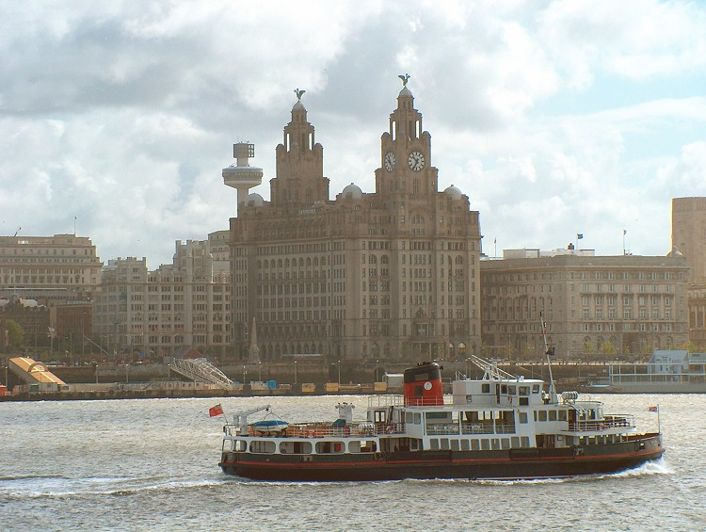
Liverpool
1. Use a material of your choice to recreate this iconic Liverpool picture.
2. Print picture and use google maps/own knowledge/books/the internet to label any part of this picture. What can you spot?

