Day | Literacy | Maths | Curriculum
Mon | Lesson 1 – Icarus  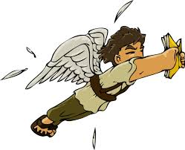  Use the following link: https://www.hamilton-trust.org.uk/blog/learning-home-packs/  > Learning at Home Packs for English  > Year 3 English Week 1  > Year 3 Day 1  Children read the story of Icarus and complete the activities about punctuating speech. | Lesson 1 – Equivalent Fractions (2)  Click on the following link:  https://whiterosemaths.com/homelearning/year-3/ and click on Summer Term Week 1 Lesson 1  Watch the video clip which explains the mathematical concepts and follow the link to ‘Get the Activity’. The children can then complete the activity and check their answers. | Stone Age Topic Lesson 1 – Step Into the Stone Age Part 1  Use a search engine or books to research the meaning of some vocabulary related to this period of time.  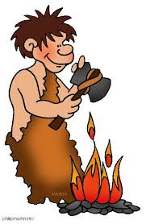  Fill in the Archaeological Dictionary on the Topic Week 1 Resources document.
Tues | Lesson 2 – Conjunctions  Use the following link: https://www.hamilton-trust.org.uk/blog/learning-home-packs/  > Learning at Home Packs for English  > Year 3 English Week 1  > Year 3 Day 2  Children read through the story of Perseus and complete the conjunctions activities. | 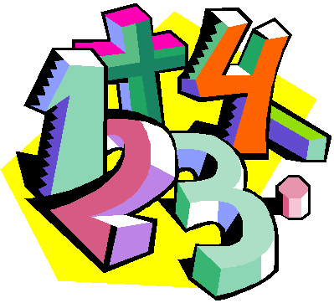  Lesson 2 – Equivalent Fractions (3)  Click on the following link:  https://whiterosemaths.com/homelearning/year-3/ and click on Summer Term Week 1 Lesson 2  Watch the video clip which explains the mathematical concepts and follow the link to ‘Get the Activity’. The children can then complete the activity and check their answers. | Stone Age Topic Lesson 1 – Step Into the Stone Age Part 2    Use a search engine like Google to find out the names and dates of the prehistoric periods.  Complete the Prehistory Detective activity on the Topic Week 1 Resources document.
Wed | Lesson 3 – Tense  Use the following link: https://www.hamilton-trust.org.uk/blog/learning-home-packs/  > Learning at Home Packs for English  > Year 3 English Week 1  > Year 3 Day 3  Children watch the clip about Perseus and the Gorgon’s Head and write their own version of the myth in the first person. | Lesson 3 – Compare Fractions  Click on the following link:  https://whiterosemaths.com/homelearning/year-3/ and click on Summer Term Week 1 Lesson 3  Watch the video clip which explains the mathematical concepts and follow the link to ‘Get the Activity’. The children can then complete the activity and check their answers. | Science Lesson 1 – Plants  Think about the plants we grow to eat (think of some examples) and about the different parts of these plants.    Sunflowers are a good example.  Use the link below as an example. Draw an accurate picture and label the different parts (roots, stem, leaves, flower).  https://www.superteacherworksheets.com/plants/plant-parts-color-poster_AAZYT.pdf?up=1466611200
Thurs | Lesson 4 – Onomatopoeia  Use the following link: https://www.hamilton-trust.org.uk/blog/learning-home-packs/  > Learning at Home Packs for English  > Year 3 English Week 1  > Year 3 Day 4  Children complete the onomatopoeia activities.  Use the writing frame to write their own poem for a place which provokes emotions, try to use onomatopoeia where they can. | Lesson 4 – Order Fractions  Click on the following link:  https://whiterosemaths.com/homelearning/year-3/ and click on Summer Term Week 1 Lesson 4 Watch the video clip which explains the mathematical concepts and follow the link to ‘Get the Activity’. The children can then complete the activity and check their answers. | Art/Design – Observational Drawing  Handwriting – Write a verse of the William Wordsworth Poem – ‘I wandered lonely as a cloud’  Observational Drawing - Use either daffodils from your garden ‘Google images’ - create an observational drawing of a daffodil to illustrate your poem.  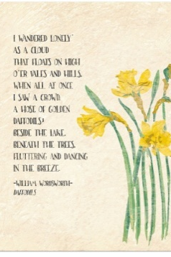
Fri | Lesson 5 – Poetry  Use the following link: https://www.hamilton-trust.org.uk/blog/learning-home-packs/  > Learning at Home Packs for English  > Year 3 English Week 1  > Year 3 Day 5  Children read ‘The Noise’ by Michael Rosen, complete the Past and Present Verbs activity.  Write their own poem about their family. | Lesson 5 – Add Fractions  Click on the following link:  https://whiterosemaths.com/homelearning/year-3/ and click on Summer Term Week 1 Lesson 5  Watch the video clip which explains the mathematical concepts and follow the link to ‘Get the Activity’. The children can then complete the activity and check their answers. | Creative Learning  We are all living through an event that will be remembered for years to come in history!  Use the link below to complete the ‘2020 Covid-19 Time Capsule’ activities.    https://letsembark.ca/time-capsule
St. Oswald’s Home Learning
Year 3: Week 1 - Week Beginning 13.4.20

